According to Intelli, the Malta medical devices market was valued at USD 100.05 million in 2024 and is projected to reach USD 109.19w million by 2032, growing at a CAGR of 1.45% during the forecast period.

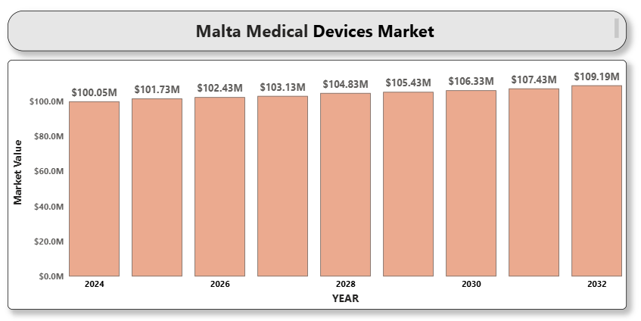

The market is driven by factors such as technological advancements in diagnostics and treatment, increasing healthcare expenditure, and Malta's alignment with European medical device regulations (EU MDR). Demand is rising for both high-end devices and basic medical supplies due to increased surgical volumes, outpatient services, and enhanced public healthcare funding.

Malta’s public healthcare system, which offers universal access, creates a stable demand for essential medical equipment. At the same time, private sector growth, especially in elective procedures and specialty care, is fueling the need for advanced diagnostic imaging systems, minimally invasive surgical tools, and digital monitoring devices.

**Malta medical devices Market Definition**

Medical devices refer to instruments, apparatuses, machines, implants, or related articles used for diagnosing, preventing, monitoring, or treating medical conditions in humans. These devices range from simple tools like thermometers and syringes to complex technologies like MRI machines, pacemakers, and robotic surgical systems.

In Malta, medical devices play a vital role in enhancing patient outcomes across healthcare facilities, including public hospitals, private clinics, and ambulatory care centers. The devices encompass diagnostic imaging tools, surgical instruments, patient monitoring systems, infusion pumps, orthopedic implants, and consumables such as catheters and wound care products.

Malta's growing healthcare demands, aging population, and rising chronic disease burden have led to increased deployment of medical devices. In line with EU regulations, the Maltese health system continues to emphasize safety, efficacy, and quality in the procurement and utilization of medical technologies.

**Malta medical devices Market Overview**

As Malta integrates more digital solutions into healthcare, including telemedicine and electronic health records (EHR), there is an uptick in demand for interoperable and smart medical devices. This shift is supported by EU-funded infrastructure improvements and local policies encouraging health technology innovation.Imports dominate the Maltese market as local manufacturing is limited. Therefore, global players benefit from partnerships with domestic distributors and participation in public tenders. Devices that meet both performance standards and affordability are favored, particularly in the public hospital segment.

Overall, Malta presents a growing yet regulated medical devices landscape where companies offering technologically advanced, cost-efficient, and compliant products are best positioned for success.

**Market Segment Analysis**

**By Device Type**

* Diagnostic Imaging Devices
* Therapeutic Devices
* Surgical Devices
* Patient Monitoring Devices
* Orthopedic Devices
* Consumables & Disposables

**By End User**

* Hospitals and Clinics
* Ambulatory Surgical Centers
* Diagnostic Centers
* Home Healthcare

**Competitive Landscape**

The Malta medical devices market is moderately fragmented, with strong representation from European and international manufacturers. Global firms collaborate with local importers and service providers to enhance accessibility and after-sales support.

The competitive edge lies in CE-marked product compliance, innovation, pricing, and support services. Companies are increasingly offering bundled services, maintenance contracts, and integrated systems compatible with Malta’s digital health infrastructure.

**Key Profiles of Malta medical devices market**

* Medtronic plc
* Siemens Healthineers
* GE HealthCare
* Philips Healthcare
* Johnson & Johnson
* Stryker Corporation
* B. Braun Melsungen AG
* Boston Scientific Corporation
* Abbott Laboratories
* Zimmer Biomet
* Canon Medical Systems
* Smith & Nephew plc
* Drägerwerk AG & Co. KGaA
* Olympus Corporation
* Baxter International Inc.
* Roche Diagnostics

**Key Developments**

* **On April 13**, 2025, EVE Healthcare in Malta, New York, reaffirmed its role as a trusted provider of comprehensive radiology services. Offering MRI, CT Scan, PET CT, and Ultrasound under one roof, the center ensures timely, accurate diagnostics essential for high-quality patient care in a fast-paced healthcare environment.
* **In 2024**, LifeScan.mt opened a new medical and radiology clinic in Naxxar, offering high-quality services including Digital X-Ray, Ultrasound, 3D Mammogram, and DEXA bone density scans—all available on-site for convenient, comprehensive care.

**Market Attractiveness**

Malta offers a stable and growing medical devices market due to its universal healthcare system, alignment with EU regulatory frameworks, and increasing demand for technologically advanced care solutions. The country’s healthcare digitization roadmap and investment in hospital infrastructure present opportunities for innovative device providers.

**Porter’s Five Forces Analysis**

* **Threat of New Entrants:** Moderate – Regulatory requirements and reliance on imports limit new local entries.
* **Bargaining Power of Suppliers:** Moderate – High-quality and specialized technologies limit supplier options.
* **Bargaining Power of Buyers:** High – Public procurement and pricing pressures shape supplier strategies.
* **Threat of Substitutes:** Low – Advanced medical devices have few effective substitutes.
* **Competitive Rivalry:** High – Multiple global players compete in a price- and innovation-sensitive market.

**Table of Contents**

1. **Introduction of Malta Medical Devices Market**
   * 1.1 Overview of the Market
   * 1.2 Scope of Report
   * 1.3 Assumptions
2. **Executive Summary**
3. **Research Methodology**
   * 3.1 Data Mining
   * 3.2 Validation
   * 3.3 Primary Interviews
   * 3.4 List of Data Sources
4. **Malta Medical Devices Market Outlook**
   * 4.1 Market Definition
   * 4.2 Market Overview
   * 4.3 Porter’s Five Forces Model
   * 4.4 Value Chain Analysis
5. **Market, by Device Type**
   * 5.1 Diagnostic Imaging Devices
   * 5.2 Therapeutic Devices
   * 5.3 Surgical Devices
   * 5.4 Patient Monitoring Devices
   * 5.5 Orthopedic Devices
   * 5.6 Consumables & Disposables
6. **Market, by End User**
   * 6.1 Hospitals and Clinics
   * 6.2 Ambulatory Surgical Centers
   * 6.3 Diagnostic Centers
   * 6.4 Home Healthcare
7. **Competitive Landscape**
   * 7.1 Overview
   * A close-up of hands holding a tablet and a pen

     Description automatically generated7.2 Company Market Ranking
   * 7.3 Key Development Strategies
8. **Company Profiles**

**8.1 Medtronic plc**  
8.1.1 Overview  
8.1.2 Financial Performance  
8.1.3 Product Outlook  
8.1.4 Key Developments

**8.2 Siemens Healthineers**  
8.2.1 Overview  
8.2.2 Financial Performance  
8.2.3 Product Outlook  
8.2.4 Key Developments

**8.3 GE HealthCare**  
8.3.1 Overview  
8.3.2 Financial Performance  
8.3.3 Product Outlook  
8.3.4 Key Developments

**8.4 Philips Healthcare**  
8.4.1 Overview  
8.4.2 Financial Performance  
8.4.3 Product Outlook  
8.4.4 Key Developments

**8.5 Johnson & Johnson**  
8.5.1 Overview  
8.5.2 Financial Performance  
8.5.3 Product Outlook  
8.5.4 Key Developments

**8.6 Stryker Corporation**  
8.6.1 Overview  
8.6.2 Financial Performance  
8.6.3 Product Outlook  
8.6.4 Key Developments

**8.7 B. Braun Melsungen AG**  
8.7.1 Overview  
8.7.2 Financial Performance  
8.7.3 Product Outlook  
8.7.4 Key Developments

**8.8 Boston Scientific Corporation**  
8.8.1 Overview  
8.8.2 Financial Performance  
8.8.3 Product Outlook  
8.8.4 Key Developments

**8.9 Abbott Laboratories**  
8.9.1 Overview  
8.9.2 Financial Performance  
8.9.3 Product Outlook  
8.9.4 Key Developments

**8.10 Zimmer Biomet**  
8.10.1 Overview  
8.10.2 Financial Performance  
8.10.3 Product Outlook  
8.10.4 Key Developments

**8.11 Canon Medical Systems**  
8.11.1 Overview  
8.11.2 Financial Performance  
8.11.3 Product Outlook  
8.11.4 Key Developments

**8.12 Smith & Nephew plc**  
8.12.1 Overview  
8.12.2 Financial Performance  
8.12.3 Product Outlook  
8.12.4 Key Developments

**8.13 Drägerwerk AG & Co. KGaA**  
8.13.1 Overview  
8.13.2 Financial Performance  
8.13.3 Product Outlook  
8.13.4 Key Developments

**8.14 Olympus Corporation**  
8.14.1 Overview  
8.14.2 Financial Performance  
8.14.3 Product Outlook  
8.14.4 Key Developments

**8.15 Baxter International Inc.**  
8.15.1 Overview  
8.15.2 Financial Performance  
8.15.3 Product Outlook  
8.15.4 Key Developments

**8.16 Roche Diagnostics**  
8.16.1 Overview  
8.16.2 Financial Performance  
8.16.3 Product Outlook  
8.16.4 Key Developments

1. **Key Developments**
   * 9.1 Product Launches/Developments
   * 9.2 Mergers and Acquisitions
   * 9.3 Business Expansions
2. **Appendix**
   * 10.1 Related Research